Supplemental Materials
Table S5
Path Estimates for the Single Mediation Model (Coparenting Only)
Model paths |  | Girls |  |  |  | Boys
 |  | β | SE | p |  | β | SE | p
Direct effects
Predictor effects
CC → EPª |  | -.007 | .047 | .839 |  | -.007 | .045 | .835
CC → PNª |  | -.006 | .040 | .843 |  | -.007 | .043 | .843
CC → IDª |  | -.009 | .057 | .843 |  | -.007 | .046 | .843
CC → CO^{d} |  | .431 | .054 | .002 |  | .404 | .048 | .002
Mediator effects
CO → EP^{b} |  | -.132 | .047 | .005 |  | -.138 | .052 | .006
CO → PN^{b} |  | -.116 | .041 | .005 |  | -.131 | .051 | .007
CO → ID^{b} |  | -.164 | .058 | .005 |  | -.142 | .054 | .008
Control variable effects
Age → EP^{g} |  | .132 | .053 | .014 |  | .137 | .052 | .012
Age → PN^{g} |  | .115 | .047 | .012 |  | .130 | .050 | .014
Age → ID^{h} |  | -.060 | .058 | .369 |  | -.052 | .050 | .356
Indirect effects
CC → EP |  | -.057 | .022 | .004 |  | -.056 | .021 | .004
CC → PN |  | -.050 | .020 | .004 |  | -.053 | .021 | .005
CC → ID |  | -.071 | .028 | .004 |  | -.057 | .022 | .005
Model fit indices |  | χ² (30) = 33.725, p = .292 ; CFI = .975; RMSEA = .021, 90% CI [.000; .051]
Squared multiple correlation |  | R² | SE | p |  | R² | SE | p
EP |  | .036 | .020 | .036 |  | .039 | .020 | .039
PN |  | .027 | .015 | .027 |  | .035 | .019 | .035
ID |  | .032 | .021 | .032 |  | .024 | .017 | .024
Note. Parameters are standardized coefficients (β). Paths constrained to equality are denoted in accordance to Figure 1, except for the excluded variable positive parenting. CC = constructive interparental conflict; CO = coparenting; EP = child emotional problems; PN = child pain; ID = child infectious diseases; Age = child age. Reported p values are all two-tailed. Significant values are bold. Squared multiple correlation = R².

Figure S1
Flow Chart of Participants
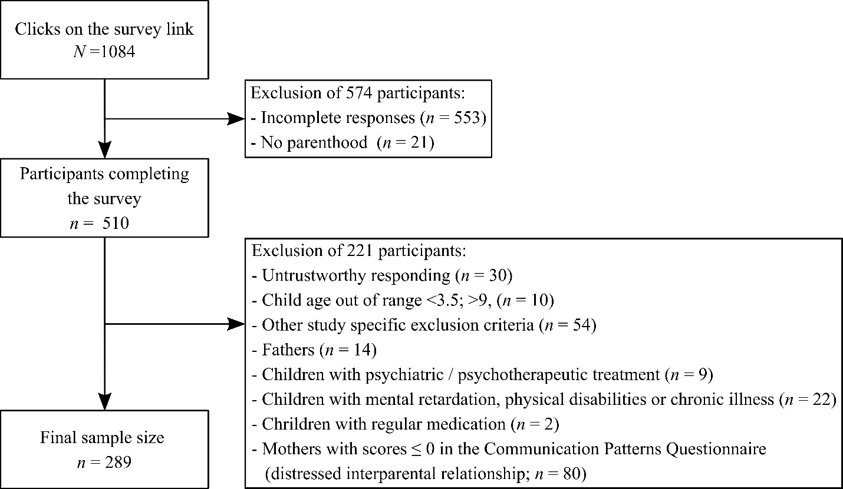
Note. “Other study specific exclusion criteria” are: no committed relationship or less than one year, no cohabitation with the current partner, and a cohabitation with the child of less than 15 days per month.

Figure S2
Single Mediation Model with Coparenting as Mediator
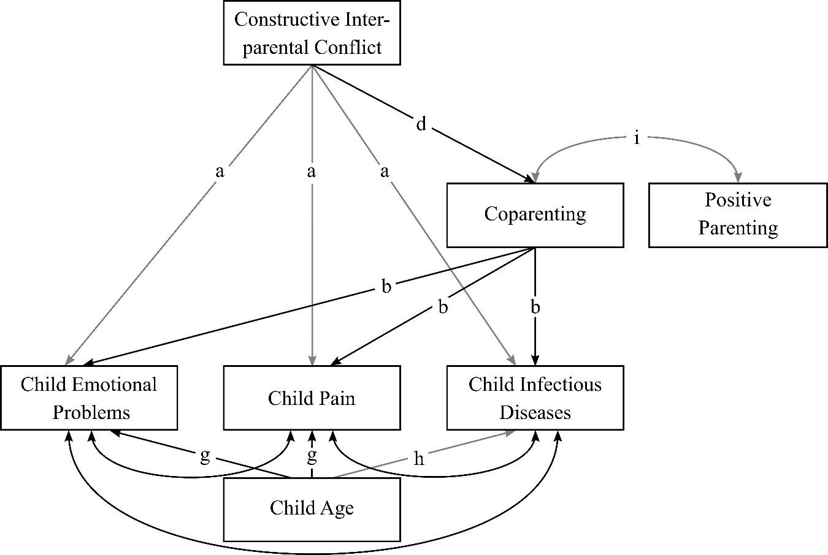
Note. Single mediation model with path fixations. Model fit of the single mediation model was: χ² (30) = 33.725, p = .292 ; CFI = .975; RMSEA = .021, 90% CI [.000; .051]. Letters indicate equalized paths for gender. Error terms of dependent variables were allowed to have shared variance. Black paths indicate significant direct effects, grey paths indicate non-significant paths. All path estimates are reported in Table S5, separated for boys and girls.

